**DAILY ONLINE ACTIVITIES SUMMARY**

|  |  |  |  |  |  |  |  |  |
| --- | --- | --- | --- | --- | --- | --- | --- | --- |
| **Date:** | **10-6-2020** | | | | | **Name:** | **poojashree** | |
| **Sem & Sec** | **8th sem A sec** | | | | | **USN:** | **4al16cs065** | |
| **Online Test Summary** | | | | | | | | |
| **Subject** | |  | | | | | | |
| **Max. Marks** | |  | | **Score** | | |  | |
| **Certification Course Summary** | | | | | | | | |
| **Course** | **Introduction to cyber security** | | | | | | | |
| **Certificate Provider** | | | **Great learning academy** | | **Duration** | | | **5.5hr** |
| **Coding Challenges** | | | | | | | | |
| **Problem Statement:**  **1.** **Implementing Bubble sort in a C Program** | | | | | | | | |
| **Status:completed** | | | | | | | | |
| **Uploaded the report in Github** | | | | | **yes** | | | |
| **If yes Repository name** | | | | | **Poojashree** | | | |
| **Uploaded the report in slack** | | | | | **yes** | | | |

**Online test**

----------not conducted---------------

**Certification course**

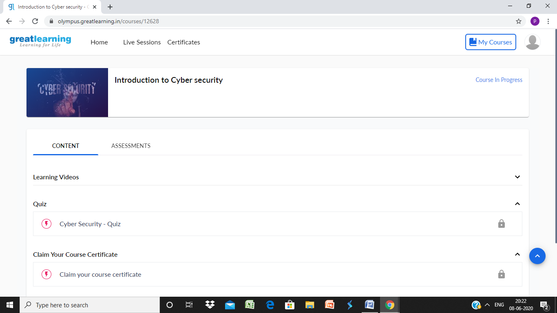

**Coding**

**Program 1**

**\* Implementing Bubble sort in a C Program**

**#include<stdio.h>**

**int main(){**

**int count, temp, i, j, number[30];**

**printf("How many numbers are u going to enter?: ");**

**scanf("%d",&count);**

**printf("Enter %d numbers: ",count);**

**for(i=0;i<count;i++)**

**scanf("%d",&number[i]);**

**/* This is the main logic of bubble sort algorithm**

**\*/**

**for(i=count-2;i>=0;i--){**

**for(j=0;j<=i;j++){**

**if(number[j]>number[j+1]){**

**temp=number[j];**

**number[j]=number[j+1];**

**number[j+1]=temp;**

**}**

**}**

**}**

**printf("Sorted elements: ");**

**for(i=0;i<count;i++)**

**printf(" %d",number[i]);**

**return 0;**

**}**